HOW GEOVERIFY WORKS
A plain-words guide for the team — read this once and you can explain the project without the slides.
1. THE WHOLE IDEA IN ONE PICTURE
A government says: we built a road here, it cost ₹20 crore, it was finished in March. GeoVerify checks that claim against satellite photos of the same spot, and says whether the ground agrees.
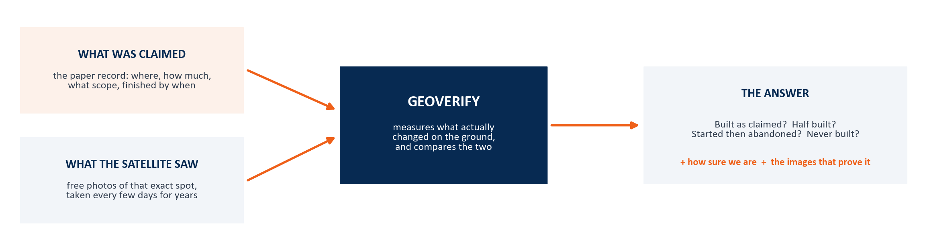
Two things make this possible, and both are free:
- Satellites photograph the whole of India every few days, and those photos go back years. Nobody can edit them afterwards.
- The photos are public. Sentinel-2 (European) and Landsat (American) cost nothing to download.
So the evidence already exists. Our job is to fetch it, measure it, and line it up against what was promised.
2. HOW IT WORKS, STEP BY STEP
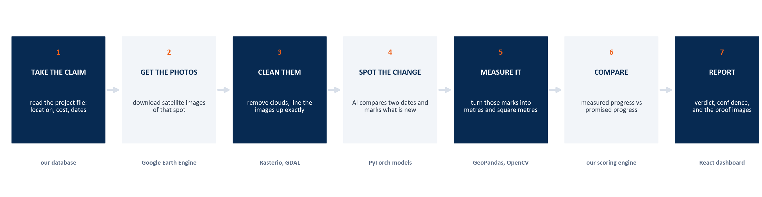
The pipeline. Each box is one module we build. Data flows left to right.
1. Take the claim
We read the project record: where it is (a point or a road line), how much money was sanctioned, what was supposed to be built, and the dates — sanctioned, started, finished.
Think of it as the promise we are going to test.
2. Get the photos
The system asks Google Earth Engine for every satellite photo of that exact location across three time windows. Earth Engine holds decades of imagery and does the searching on its servers, so we never download a whole country.
Like asking a huge photo library: show me this street corner, every photo you have, from 2023 to 2025.
3. Clean them
Photos come with clouds, shadows and slight shifts in alignment. We mask out cloud, merge several photos of the same window into one clean picture, and align every image to the same grid so a pixel means the same place in every photo.
If the images are not lined up perfectly, the AI will think a tree moved and call it construction.
4. Spot the change
Two cleaned images of the same place, different dates, go into the model. It outputs a mask — a black-and-white picture where white means 'something here is new'.
This is the classic spot-the-difference game, done by a neural network instead of your eyes.
5. Measure it
A white blob is not an answer. We convert it into real units: how many metres of road, how wide, or how many square metres of building. Each pixel of Sentinel-2 is 10 metres by 10 metres, so counting pixels gives us area and length.
This is the step that makes us different from published research, which stops at step 4.
6. Compare
Now we have measured progress at six or seven points in time. We draw that as a curve and put the promised curve next to it — 0% on the start date, 100% on the claimed completion date. The gap between the two curves is the finding.
Promise versus reality, on one graph.
7. Report
The system outputs a verdict, a discrepancy score, a confidence value, and the images that justify it — all viewable on a dashboard and exportable as a PDF.
An auditor should be able to disagree with us, look at our images, and see exactly why we said what we said.
3. WHY WE LOOK AT THREE TIME WINDOWS
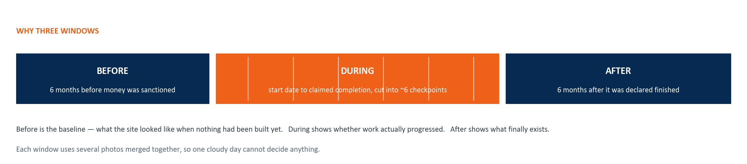
One photo proves nothing. A building in a photo could have been there for ten years. What proves construction is the change between photos — which is why we always compare a before, a during and an after.
If a window has too few usable photos, say the whole monsoon was cloudy, we do not guess. The confidence value drops and the dashboard shows the verdict as unreliable.
4. THE FOUR ANSWERS, AND HOW WE TELL THEM APART
Every project ends up in one of four states. They are separated by the shape of the measured curve, not by a single number.
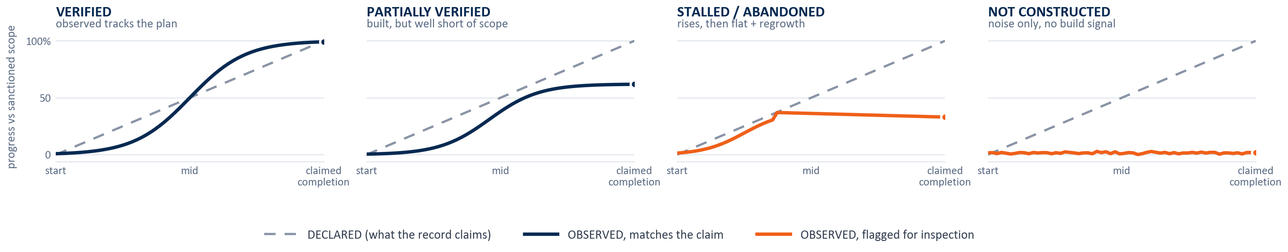
Grey dashed line = what was promised. Solid line = what we measured.
State | What the curve does | What it probably means
Verified | Rises and reaches the promised level | The work looks genuinely done
Partially verified | Rises but settles well below the promise | Something was built, but much smaller than sanctioned
Stalled / abandoned | Rises early, then goes flat; plants grow back over bare soil | Work started, money may have moved, then it stopped
Not constructed | Never rises at all, just noise | No sign of construction at that location
The vegetation clue matters. On an abandoned site the soil is disturbed first, then greenery slowly returns. That regrowth pattern is visible from space and is a strong hint that work stopped rather than finished.
5. THE TECH STACK, EXPLAINED SIMPLY
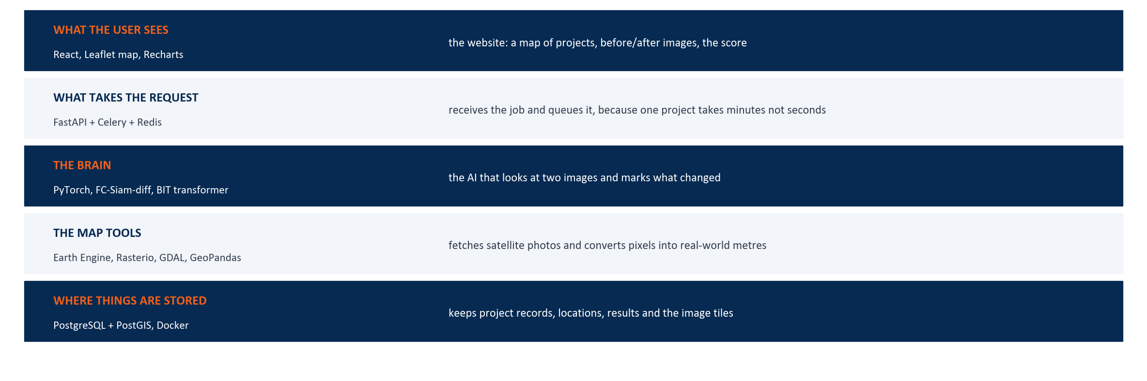
Five layers. Each one has a job, and the tools under it are just the tools that do that job.
What happens when someone uses the system
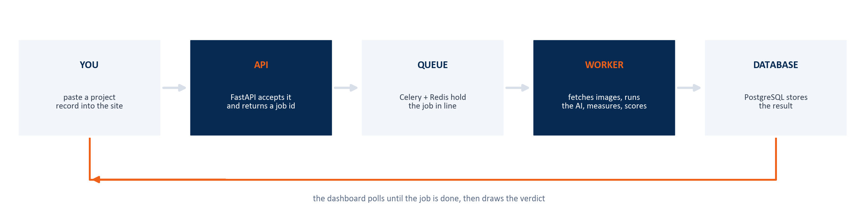
A project takes several minutes to check, because we are downloading and processing dozens of satellite photos. So we never make the user wait on a loading screen. The request gets queued, a worker does the heavy lifting in the background, and the page updates when the result is ready.
Every tool, and why it is there
Tool | What it actually is | Why we use it
Python | The programming language everything is written in | Every satellite and AI library we need already exists in Python
React + Vite | Tools for building the website the user sees | Makes the dashboard fast and easy to update
Leaflet | A map library | Shows projects as pins on an actual map instead of a boring list
Recharts | A charting library | Draws the promised-vs-measured progress curve
FastAPI | The web server that receives requests | Fast, simple, and written in Python like the rest of our code
Celery + Redis | A job queue — a waiting line for slow tasks | One project takes minutes; the queue runs it in the background
Google Earth Engine | Google's archive of satellite imagery, with servers to process it | Free access to decades of Sentinel-2 and Landsat, without downloading terabytes
Sentinel-2 | European satellite, photographs everywhere every 5 days at 10 m detail | Our main source of images — free and frequent
Landsat 8/9 | American satellites, coarser (30 m) but going back decades | Used for older baselines where Sentinel-2 did not exist yet
Rasterio + GDAL | Libraries for reading and writing satellite image files | Satellite images are not JPEGs; they carry coordinates and many colour bands
GeoPandas | A spreadsheet library that understands shapes and locations | Lets us work with road lines and site boundaries as data
PyTorch | The library used to build and train AI models | Industry standard for deep learning, and free
TorchGeo | PyTorch add-on made for satellite data | Handles the awkward parts of feeding imagery into a model
FC-Siam-diff | A change-detection model (our baseline) | Simple and fast; if our fancy model cannot beat it, we have learnt something
BIT transformer | A newer change-detection model (our main one) | Better at long thin things like roads, which is exactly our case
OpenCV | A general image-processing toolkit | Cleaning masks, measuring shapes, basic image operations
PostgreSQL + PostGIS | A database that understands geography | Stores projects, coordinates and results, and can answer questions like 'what is within 200 m of this point'
Docker | A way to package software so it runs the same everywhere | Our laptops, the college machine and the server all behave identically
QGIS | Desktop mapping software | For manually eyeballing a site when we are checking our own results
6. IF SOMEONE ASKS YOU IN THE CORRIDOR
The 20-second version
Governments announce that roads and buildings are finished, and the proof is paperwork from the same contractor being paid. We use free satellite photos to check whether the construction actually happened, and flag the projects where the ground does not match the claim.
The 60-second version
Every few days, satellites photograph all of India, and those photos are free and public. So for any government project we can pull images from before it started, while it was being built, and after it was declared finished.
An AI model compares those images and marks what changed. We convert those marks into real measurements — kilometres of road, square metres of building — at several points in time, which gives us a progress curve.
Then we put that curve next to the promised one. If they match, the project is verified. If our curve stops halfway, it was partly built. If it rises and then goes flat while plants grow back, it was abandoned. If nothing ever changes, it was never built.
The output is a score with imagery to back it up. It is not proof of fraud — it is a way for an auditor to know which sites to visit first.
If someone asks what your part is
Pick your slide and say it in one line. For example: “I work on the imagery pipeline — fetching the right photos from Earth Engine, removing clouds, and lining the images up so the AI is comparing the same ground.”
7. WORDS THAT COME UP
Word | Plain meaning
Satellite imagery | Photos of the Earth taken from space
Resolution (10 m) | One pixel covers 10 metres by 10 metres of ground. Smaller number = more detail
Revisit time | How often a satellite photographs the same place again. Sentinel-2 is about 5 days
Change detection | Comparing two photos of the same place taken at different times, and marking what is new
Mask | A black-and-white image where white marks the interesting parts
Epoch | One point in time in our series — we take about six between start and claimed completion
Progress curve | A graph of how much was built, over time
Composite | Several photos of the same window merged into one clean, cloud-free picture
Co-registration | Shifting images slightly so the same pixel means the same place in all of them
Cloud masking | Deleting the cloudy parts of a photo so they are not mistaken for change
Model / neural network | A program that learnt a task from examples instead of being given rules
Training / fine-tuning | Teaching the model using thousands of labelled example image pairs
Benchmark dataset | A public set of examples everyone tests on, so results can be compared fairly
LEVIR-CD, WHU, OSCD | The three benchmark datasets we train and test on
F1 score | A single number for accuracy that balances false alarms against missed detections
Confidence | How much the system trusts its own answer, based on cloud cover and model agreement
Ground truth | The correct answer, decided by humans, used to check whether the system is right
Rule of thumb for the viva: if you cannot explain a tool in one sentence without using another technical word, you do not need to mention it.

